Name: Aaryan Pujara

ID: 102599490

1) A computer storage that only saves data that can be read only and not writable (also known as non-volatile data) is called ROM. The primary use of ROM is to store firmware which is a set of guides for computer to perform.

2) RAM is a storage media where data can be written and read and it is only stored for a temporary period of time.

Difference between RAM & ROM is:

* RAM is read and writable whereas ROM is only readable
* RAM performs faster than ROM
* Ram is usually heavy capacity unlike ROM

3)

|  |  |
| --- | --- |
| Dynamic | Static |
| Dynamic RAM is made of a large number of cells, which are made up of transistors and capacitors. Dynamic RAM takes less space and are cheap to build and needs to be refreshed constantly. | Static RAM is made of flip-flops and doesn’t need capacitors. They take up a lot of space and are expensive to build and operate. They don’t have to be refreshed. |

4) USB Thumb drives use Flash memory (also known as EEPROM). It is a good device to transfer and save small amounts of data but it is not good to be used in long run as the electrons pierce through the barrier layers which eventually breaks down barrier layer and have a small read and write life.

5) log2(n) bits addresses n bytes, so

Now 1024 = 2^10

And we need 20 bits to address every megabyte

So, we need 30 bits to address all the bytes

6) Von Neumann Architecture: It requires the use of stack in a way that the control and data bits share memory space. This Architecture lets pause and resume tasks based on their priority and the execution time for the tasks are longer because of the same reason as the data is extracted by one single data bus.

Harvard Architecture: The data and controls bits are stored separately therefore the data and control busses works uninterrupted from each other therefore making the process much for efficient. Because of complicated structure it is more expensive than the other.

7) Cache memory is a chip-based memory. It functions by making a temporary storage that computer can access easily basically making a bridge between RAM and CPU and pass the data to CPU on demand.

8) interrupt is a phenomenon that is caused when a user request to execute a task while CPU is already executing one.

Types:

* GUI Events
* Hardware
* SysCall
* Exception

9) When CPU waits for an external device to send a service request and then starts servicing the device one by one depending on the service is called Polling. It is not used commonly as if there are too many devices connected then the wait time to service each device exceeds the time available to actually serve them.

10) A stack is a structure where the requests are kind of listed as a stack and are being addressed and cleared by push and pop principle. Pushing moves and adds services to the stack and pop removes them after being addressed.

11) Stacks are used in programming to store data. Stack makes a list of function calls and parameters that are often used in programming. The execution of these functions are done similarly by the push and pop method.

12) 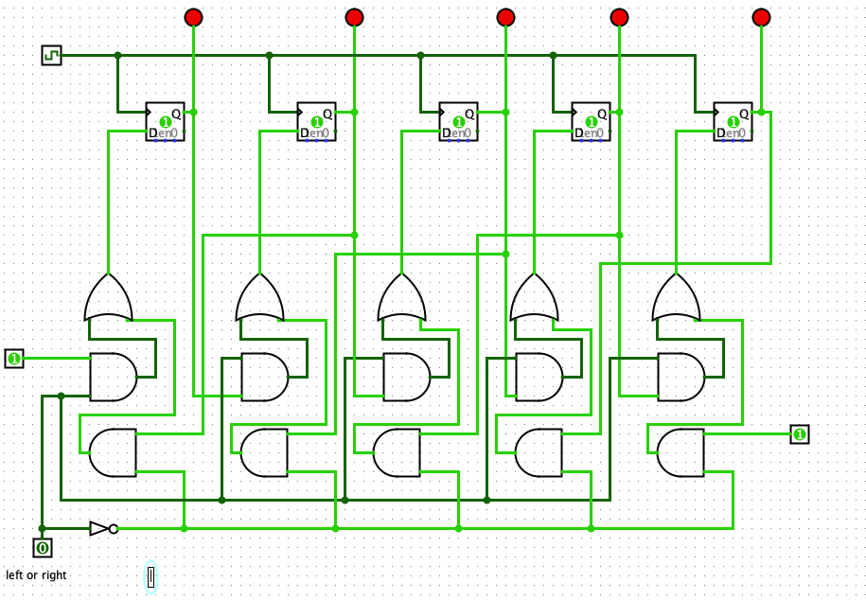

13)